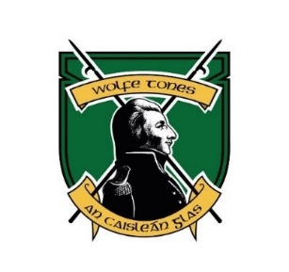

CRUINNIÚ BLIANTÚIL (2021)

(Annual General Meeting)

AINMIÚCHÁIN
(Nominations)

(To be returned on, or before, (16th January 2021)

Oifig/Officership/Position: | Ainmniúcháin/Nominee:

Cathaoirleach/Chairperson
Leas-Chathaoirleach/Vice-chairperson
An Rúnaí/Secretary
An Rúnaí Cúnta/Assistant-Secretary
An Cisteoir/Treasurer
An Cisteoir Cúnta/Assistant-Treasurer
Cláraitheoir / Registrar
C.P.O / P.R.O.
Ionadaí na nImeoirí/Players Representative
Oifigeach Gaeilge agus Cultúr/ Language & Culture Officer | Appointed on the recommendation of the outgoing Executive Committee - not an elected position
Oifigeach na Leanaí/Children’s Officer | Appointed on the recommendation of the outgoing Executive Committee – not an elected position
An Coiste/Committee

Sínithe/Signed: ___________________________________

Ainm/Name

